T H E S O N G S
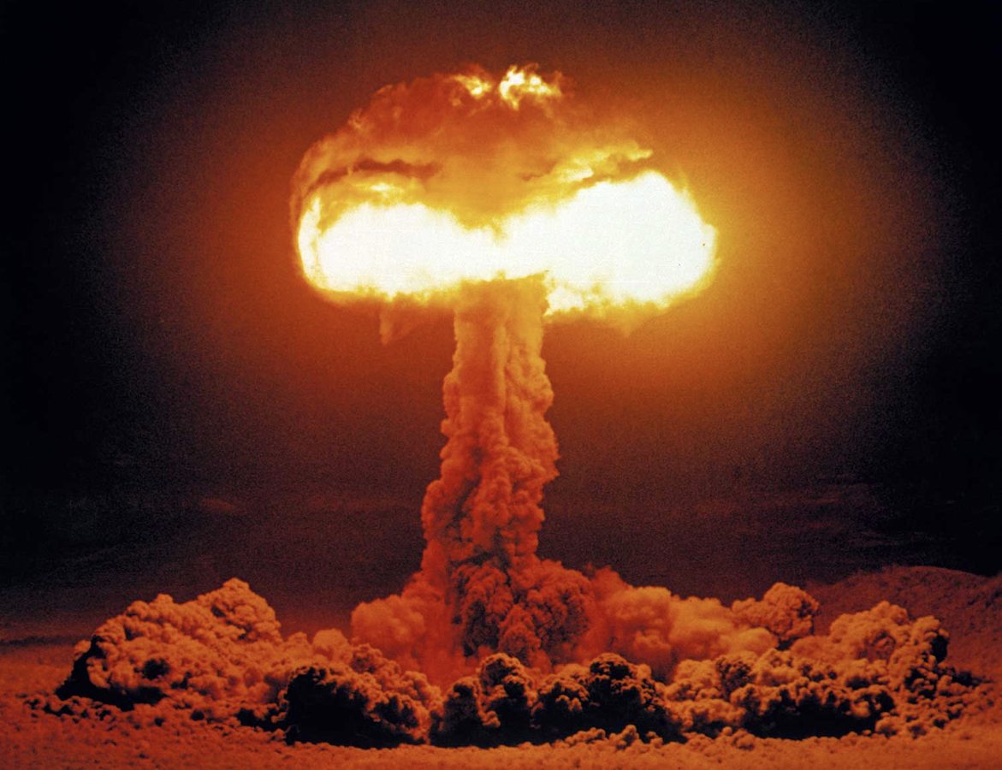

- Fireball – Lyric
- Fireball – PDF Score
- Fireball – Sibelius Score
- Fireball – Video
- Fireball – Audio + Vocal
- Fireball – Instrumental

Fireball – Lyric
Nine, eight, seven, six, five, four, three, two, one!
Push that button
Let it be done!
Look out – here it comes!

Fireball – burning in the sky
Building ever higher, are we going to die?
Fireball – rising from the ground
Growing ever brighter
Why is there no sound?
Fireball!
Where’s my child
Where’s my home
Where’s the street I used to know?
How can it be - ?
How can a city disappear?

Fireball! Fireball! Fireball!

Will I be the only survivor?
Lost in a world – a sea of burning fire?
Will I be the only one?
Oh dear God! – what have we done?

Nine, eight, seven, six, five, four, three, two, one!
Let it Go!
Let it be done!
Look out!! – here it comes!

Fireball! – glowing and alive
Pushing out its poison – nothing will survive!!
Fireball! – bursting into flames!
My body is on fire
But I feel no pain - !!
Fireball! Fireball! Fireball!

